**WEEK 1 MANDATORY HANDS-ON**

**MODULE 1: DESIGN PATTERNS AND PRINCIPLES**

Exercise 1: Implementing the Singleton Pattern

* 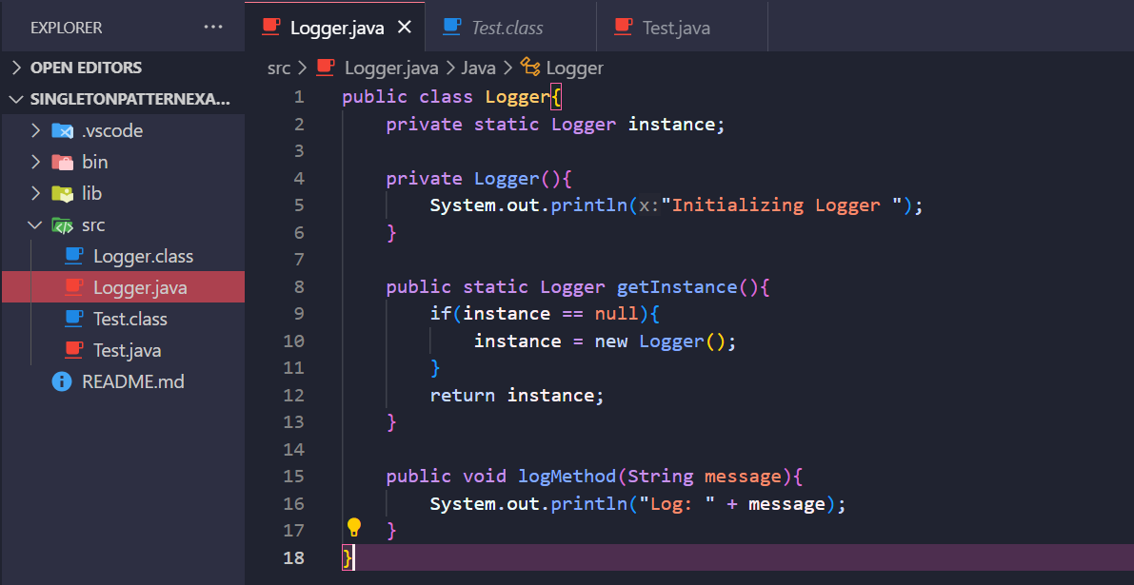Logger class
* Test class

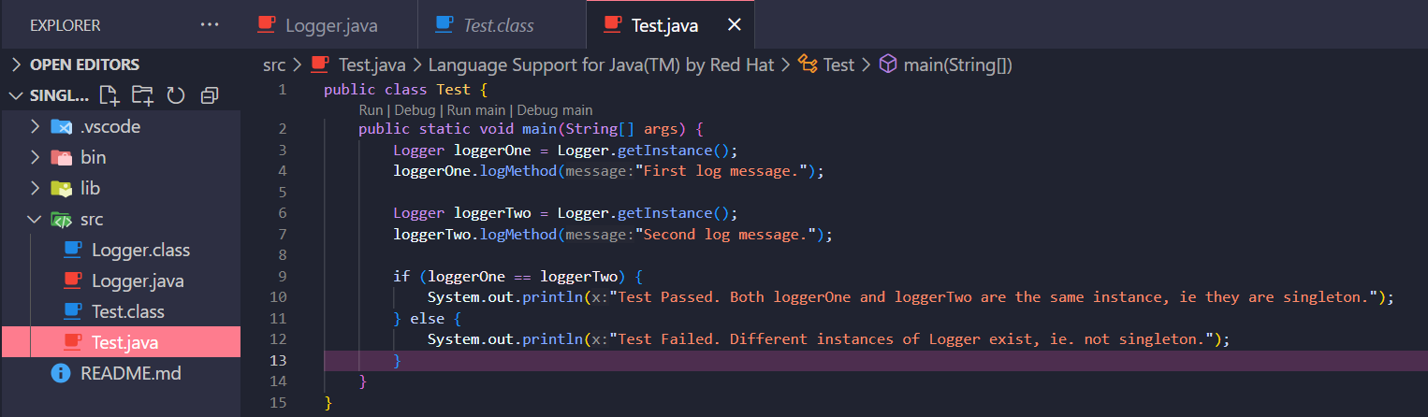

* 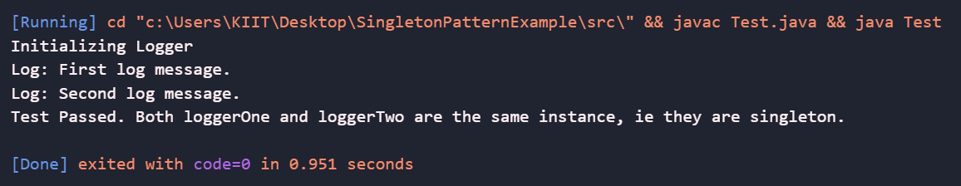Output

**Exercise 2: Implementing the Factory Method Pattern**

* Define Document interface

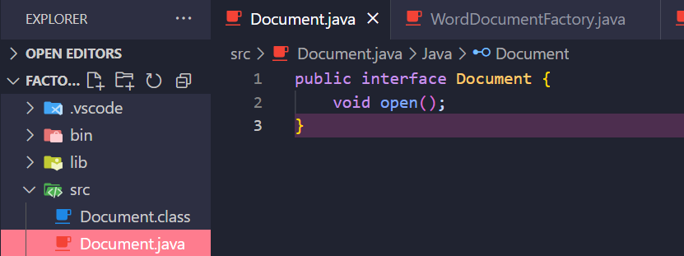

* Concrete classes for each document type **WordDocument**, **PdfDocument**, and **ExcelDocument,** that implement the Document Interface
* 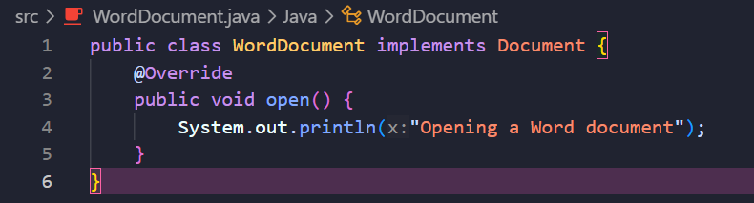WordDocument
* PdfDocument

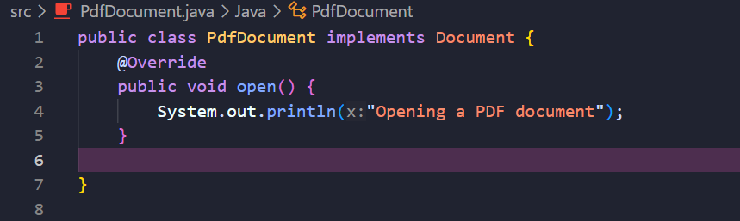

* 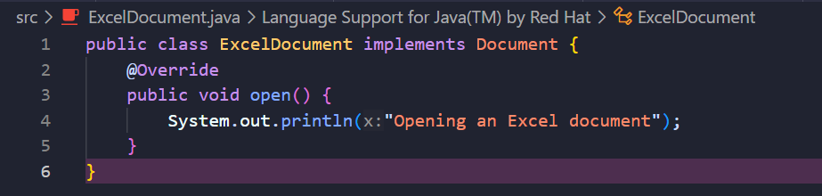ExcelDocument
* 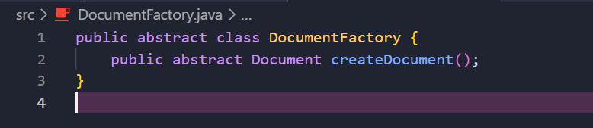DocumentFactory abstract class
* Concrete factory classes for each document type that extends DocumentFactory and implements the **createDocument()** method:
* 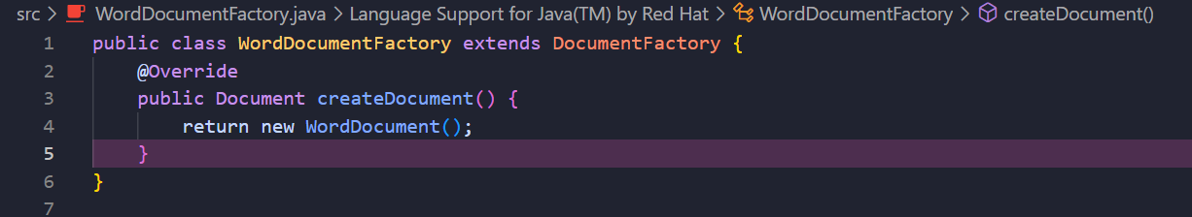WordDocumentFactory
* 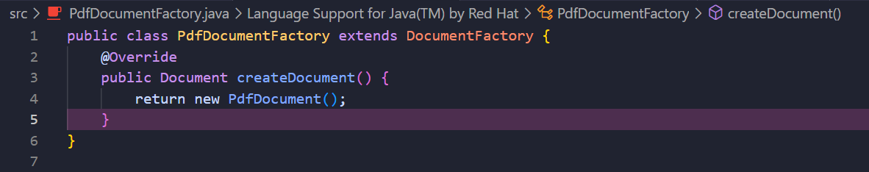PdfDocumentFactory
* ExcelDocumentFactory

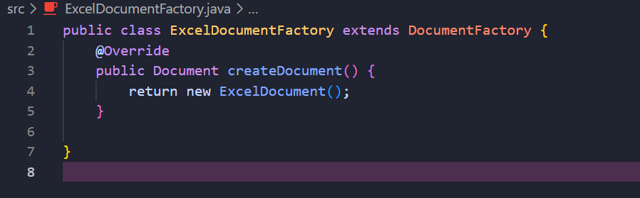

* Test class

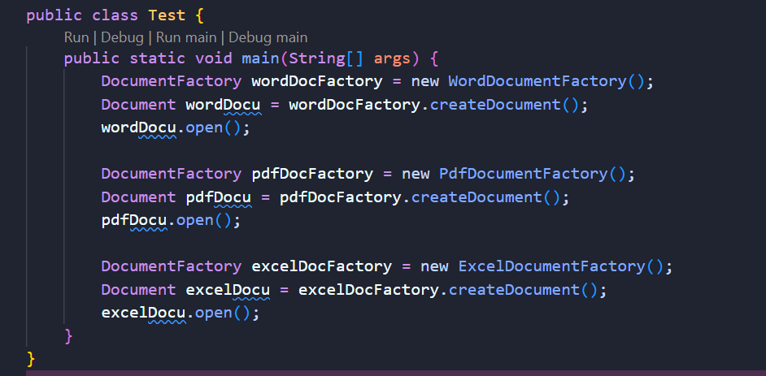

* Output showing different document types using the factory method

